EX.NO:06 | SUPPORT TICKET SYSTEM
DATE:

1.AIM:
To develop a Support Ticket System using HTML, Bootstrap, and JavaScript that allows users to raise support tickets and track their status while enabling administrators to manage and respond to tickets.
2.PROCEDURE:
Step 1 :Create an HTML page and design the interface using Bootstrap for responsive layout.
Step 2 : Develop a ticket submission form to collect user details, subject, and issue description.
Step 3 :Use JavaScript classes to create and manage ticket objects.
Step 4 : Store ticket data in localStorage for persistent storage.
Step 5 : Implement an admin panel to update ticket responses, change ticket status, and delete tickets.
Step 6 : Provide a ticket tracking feature for users to check the status using their ticket ID.
3.PROGRAM SOURCE CODE:
Ticket.html
<!DOCTYPE html>
<html lang="en">
<head>
<meta charset="UTF-8">
<title>Support Ticket System</title>
<meta name="viewport" content="width=device-width, initial-scale=1">
<link href="https://cdn.jsdelivr.net/npm/bootstrap@5.3.2/dist/css/bootstrap.min.css" rel="stylesheet">
<style>
body{
background:#f4f6f9;
}
.navbar{
background:#343a40;
}

.ticket-card{
border-left:5px solid #0d6efd;
}

.status-open{ color:#dc3545; font-weight:bold; }
.status-progress{ color:#ffc107; font-weight:bold; }
.status-resolved{ color:#198754; font-weight:bold; }
.section-title{
background:#ffffff;
padding:10px;
border-radius:8px;
margin-bottom:15px;
}
</style>
</head>
<body>
<nav class="navbar navbar-dark">
<div class="container-fluid">
<span class="navbar-brand mb-0 h1">Support Ticket System</span>
</div>
</nav>

<div class="container mt-4">

<div class="row">

<!-- USER PANEL -->
<div class="col-md-5">
<div class="section-title">
<h4>Raise New Ticket</h4>
</div>

<form id="ticketForm">
<input type="text" id="username" class="form-control mb-2" placeholder="Your Name" required>
<input type="email" id="email" class="form-control mb-2" placeholder="Email" required>
<input type="text" id="subject" class="form-control mb-2" placeholder="Subject" required>
<textarea id="message" class="form-control mb-2" placeholder="Describe your issue" required></textarea>
<button class="btn btn-primary w-100">Submit Ticket</button>
</form>

<hr>

<h5>Track Ticket</h5>
<input type="number" id="trackId" class="form-control mb-2" placeholder="Enter Ticket ID">
<button onclick="trackTicket()" class="btn btn-dark w-100">Track Status</button>
<div id="trackResult" class="mt-3"></div>
</div>

<!-- ADMIN PANEL -->
<div class="col-md-7">
<div class="section-title">
<h4>Admin Panel</h4>
</div>

<div id="ticketList"></div>
</div>

</div>
</div>

<script>
class Ticket {
constructor(id, username, email, subject, message) {
this.id = id;
this.username = username;
this.email = email;
this.subject = subject;
this.message = message;
this.status = "Open";
this.response = "";
}
}

let tickets = JSON.parse(localStorage.getItem("tickets")) || [];

const ticketForm = document.getElementById("ticketForm");
const ticketList = document.getElementById("ticketList");

ticketForm.addEventListener("submit", function(e){
e.preventDefault();

const newTicket = new Ticket(
Date.now(),
username.value,
email.value,
subject.value,
message.value
);

tickets.push(newTicket);
localStorage.setItem("tickets", JSON.stringify(tickets));

alert("Ticket Submitted! Your Ticket ID: " + newTicket.id);

ticketForm.reset();
displayTickets();
});

function displayTickets(){
ticketList.innerHTML = "";

tickets.forEach(ticket => {

let statusClass = "";
if(ticket.status === "Open") statusClass = "text-danger fw-bold";
else if(ticket.status === "In Progress") statusClass = "text-warning fw-bold";
else statusClass = "text-success fw-bold";

ticketList.innerHTML += `
<div class="card mb-3 p-3 shadow-sm">
<h5>#${ticket.id} - ${ticket.subject}</h5>
<p><b>User:</b> ${ticket.username} (${ticket.email})</p>
<p>${ticket.message}</p>

<p>Status: <span class="${statusClass}">${ticket.status}</span></p>
<p><b>Response:</b> ${ticket.response || "No response yet"}</p>

<textarea id="response-${ticket.id}"
class="form-control mb-2"
placeholder="Write response...">${ticket.response}</textarea>

<button class="btn btn-primary btn-sm mb-2"
onclick="updateResponse(${ticket.id})">
Update Response
</button>

<select class="form-select mb-2"
onchange="changeStatus(${ticket.id}, this.value)">
<option value="Open" ${ticket.status=="Open"?"selected":""}>Open</option>
<option value="In Progress" ${ticket.status=="In Progress"?"selected":""}>In Progress</option>
<option value="Resolved" ${ticket.status=="Resolved"?"selected":""}>Resolved</option>
</select>

<button class="btn btn-danger btn-sm"
onclick="deleteTicket(${ticket.id})">
Delete Ticket
</button>
</div>
`;
});
}

function updateResponse(id){
const textarea = document.getElementById(`response-${id}`);
const ticket = tickets.find(t => t.id === id);

ticket.response = textarea.value;
localStorage.setItem("tickets", JSON.stringify(tickets));

alert("Response Updated Successfully!");
displayTickets();
}

function changeStatus(id, status){
const ticket = tickets.find(t => t.id === id);
ticket.status = status;
localStorage.setItem("tickets", JSON.stringify(tickets));
displayTickets();
}
function deleteTicket(id){
tickets = tickets.filter(t => t.id !== id);
localStorage.setItem("tickets", JSON.stringify(tickets));
displayTickets();
}
function trackTicket(){
const id = parseInt(document.getElementById("trackId").value);
const resultDiv = document.getElementById("trackResult");
const ticket = tickets.find(t => t.id === id);

if(ticket){
resultDiv.innerHTML = `
<div class="alert alert-info">
<p><b>Subject:</b> ${ticket.subject}</p>
<p><b>Status:</b> ${ticket.status}</p>
<p><b>Response:</b> ${ticket.response || "No response yet"}</p>
</div>
`;
} else {
resultDiv.innerHTML = `
<div class="alert alert-danger">
Ticket not found.
</div>
`;
}
}
displayTickets();
</script>
</body>
</html>
4.SAMPLE INPUT / OUTPUT :
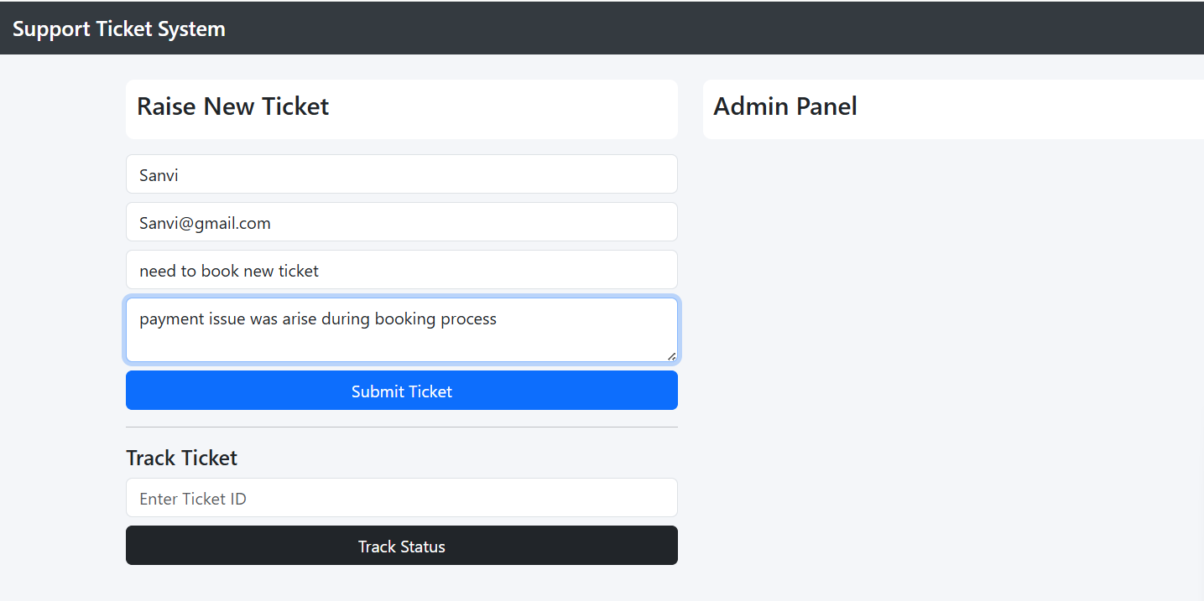

After submit a ticket,it show alert box for Ticket ID
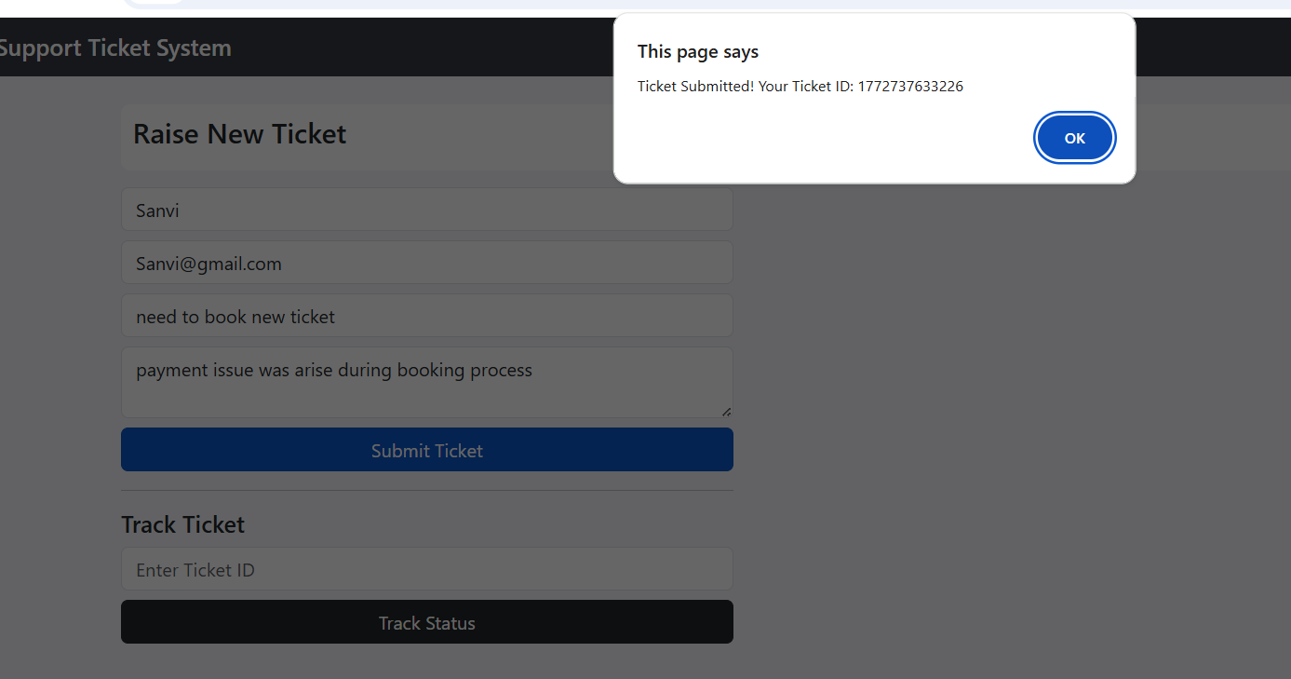
Then for understand a ticket status
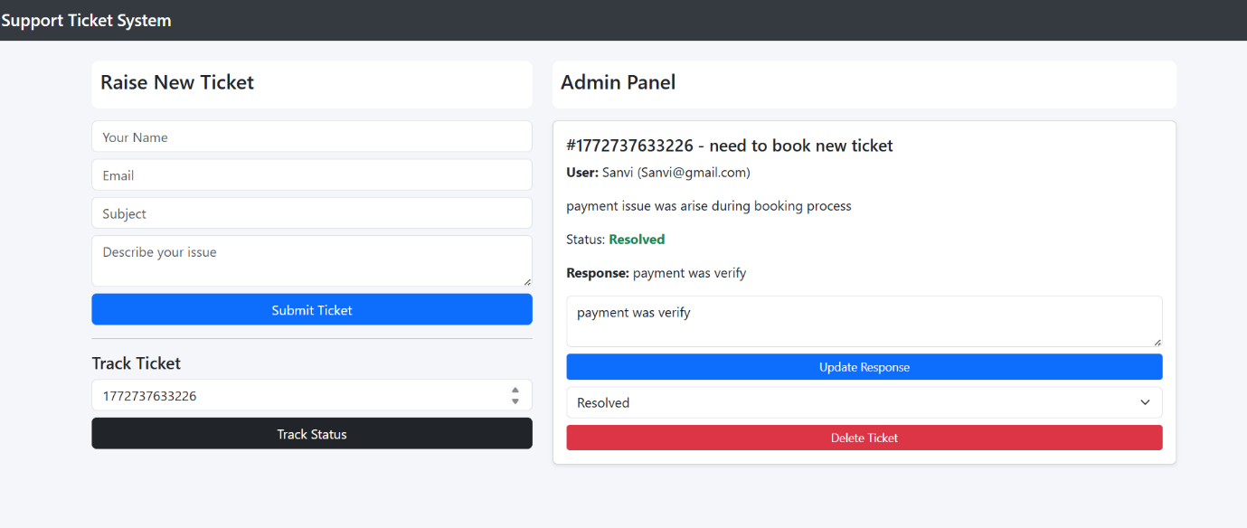

5.RESULT :
The Support Ticket System was successfully developed. Users can submit support requests and track their ticket status, while administrators can manage tickets by updating responses and changing their status.

